**Star Wars (Star Ship – Amount Stop Calculation)**

**User Manual**

After run the program, you will be asked for the distance in MGLT:

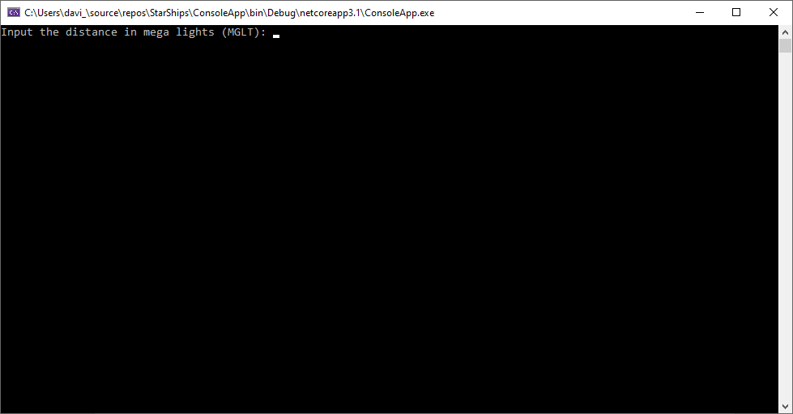

Enter with a number valid and grander than zero and press the key “ENTER”:

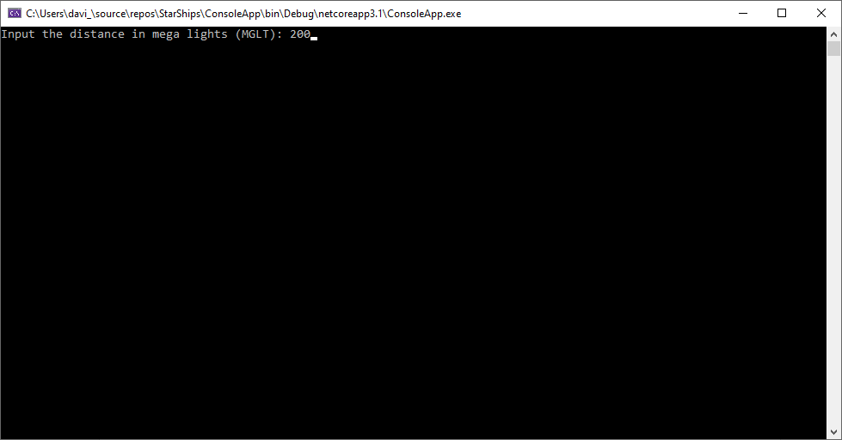

The data will be consulted, the calculation will be done and the output will return to the user:

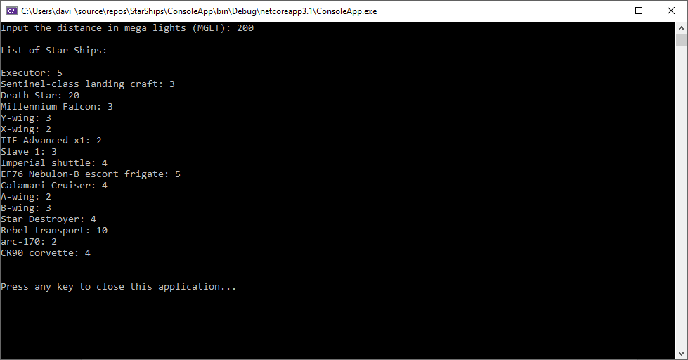

Press any key to close the application.

Obs: If you enter with any invalid data, you will be asked again for the correct value:

